“LEARNING PLATFORM WITH SMART STUDY PLANNER”
A Project Report
Submitted to


Mponline Limited, Bhopal

Submitted Malti Solanki - 0805CS221060

Under the supervision of
Mr. Dhruv Pandey Sir
Mr. Tulsiram Vishvakarma Sir

JAWAHARLAL INSTITUTE OF TECHNOLOGY, BORAWAN
Department of Computer Science & Engineering



RECOMMENDATION

This is to certify that the work embodied in this Major Project entitled “Learning Platform with smart study Planner”, being submitted by Malti Solanki (Enrollment No. 0805CS221060) in partial fulfilment of the requirement for the award of Bachelor of Technology in Computer Science & Engineering discipline, to Mponline Limited, Bhopal (M.P.) during the academic year 2025-26.

JAWAHARLAL INSTITUTE OF TECHNOLOGY, BORAWAN
Department of Computer Science & Engineering



CERTIFICATE

The Project entitled “Learning Platform with smart study Planner” being submitted by Malti Solanki Enrollment No. 0805CS221060 has been examined by us and is hereby approved for the award of the degree Bachelor of Technology in Computer Science & Engineering discipline, for which it has been submitted. It is understood that by this approval the undersigned do not necessarily endorse or approve any statement made, opinion expressed or conclusion drawn there in, but approve the Project only for the purpose for which it has been submitted.

Acknowledgement

Apart from my own efforts, the success of this report depends largely on the encouragement and guidelines of many others. I am especially grateful to my supervisor Dhruv Pandey sir , from Mponline limited , Bopal(M.P), for his comment and direction in my research work.
We express my heartful reframe to Tulsiram Vishavkarma sir for providing all the facilities reframe this project work and for his stimulating supervision whenever required during my Project work.

Malti Solanki

A Demo Video Showcasing

[Click here to watch the demo video]
https://drive.google.com/file/d/11d9PFQ0USQgyXE8jx6voq7AnsJvIZF70/view?usp=sharing]

TABLE OF CONTENTS

Introduction

Problem Statement

Objectives of the Project

Scope of the Project

5. Existing System

6. Proposed System

7. Functional Requirements

8. Non-Functional Requirements

9. Technology Stack

10. System Architecture

11. Database Design

12. Module Description

13. Use Case Diagram

14. Class Diagram

. Security Features
16. Snapshot
17.Conclusion

ABSTRACT

The Learning Platform with Smart Study Planner is a web-based application developed to improve student productivity and learning management. The system combines educational features with smart scheduling and productivity analytics. Students can manage courses, create study plans, track progress, upload notes, attend quizzes, and receive reminders. The platform also includes an admin module for monitoring users and managing the system.

The project is developed using React.js for frontend development, FastAPI for backend services, MySQL for database management, and JWT authentication for secure login functionality. The system aims to improve learning consistency, time management, and academic performance through intelligent digital tools.

INTRODUCTION

The Learning Platform with Smart Study Planner is a modern web application designed to help students organize their studies efficiently. The system provides a centralized platform where students can manage courses, create schedules, track progress, upload notes, and participate in quizzes.

The platform integrates smart planning features with educational management. It helps students maintain consistency and improve academic productivity through intelligent scheduling and reminders. The system also allows administrators to monitor users and manage educational content effectively.

The application focuses on improving time management and reducing academic stress through automation and productivity analytics.

PROBLEM STATEMENT
Students often face several academic management problems such as:
- Difficulty in managing multiple subjects
- Missing assignment deadlines
- Lack of productivity tracking
- Poor study planning
- Inefficient time management
- Lack of performance monitoring
Traditional learning systems mainly provide study material but do not support intelligent scheduling and productivity analysis. Due to these limitations, students struggle to maintain consistency in learning.
The proposed system solves these problems by introducing smart scheduling, reminders, progress tracking, and productivity
monitoring features.

OBJECTIVES OF THE PROJECT

The main objectives of the project are:
- To develop an efficient learning management system
- To provide smart study planning functionality
- To improve student productivity
- To monitor learning progress
- To generate productivity reports
- To provide reminders and notifications
- To improve time management skills
- To support academic consistency
The project also aims to simplify educational task management through automation and analytics.

SCOPE OF THE PROJECT
The project scope includes:
- User authentication system
- Course management
- Study planner
- Quiz management
- Notes management
- Progress tracking dashboard
- Notifications and reminders
- Productivity analytics
- Admin monitoring system
- Weak subject analysis
The system can be used in schools, colleges, and personal learning environments.

EXISTING SYSTEM
Existing learning platforms mostly focus only on content delivery. They provide study material
do not help students manage study schedules or productivity.

Limitations of Existing Systems
- No intelligent scheduling
- Lack of productivity analytics
- Poor task management
- No personalized planning
- Limited performance monitoring
Because of these limitations, students often depend on manual planning methods.

PROPOSED SYSTEM
The proposed system combines learning management with smart planning features. The application allows students to create tasks, manage courses, upload notes, attend quizzes, and
track progress.

Features of Proposed System
- Smart study planner
- Personalized scheduling
- Productivity tracking
- Weak subject analysis
- Reminder notifications
- Quiz and notes management
- Admin analytics dashboard
The system enhances learning efficiency and academic performance.

FUNCTIONAL REQUIREMENTS
User Authentication
- User registration
- Login and logout
- JWT authentication
- Password validation
Course Management
- Add courses
- Update courses
- Delete courses
Study Planner
- Create tasks
- Set priorities
- Generate schedules
Quiz Module
- Attend quizzes
- Automatic score calculation
- Performance reports
Notes Module
- Upload notes
- Download notes
- Organize notes subject-wise
Admin Module
- Manage users
- Monitor reports
- Manage platform content

NON-FUNCTIONAL REQUIREMENTS
Performance
The application should provide fast response time.
Security
The system should use JWT authentication and encrypted passwords.
Reliability
The system must work efficiently without failures.
Scalability
The platform should support increasing users.
Usability
The interface should be user-friendly and responsive.

TECHNOLOGY STACK
Frontend Technologies
- React.js
- HTML
- CSS
- JavaScript
Backend Technologies
- FastAPI
- Python
Database
- MySQL
Authentication
- JWT Authentication
Version Control
- Git & GitHub

SYSTEM ARCHITECTURE
The system follows a client-server architecture.
Components
Frontend
Handles user interface and interaction.
Backend
Processes requests and business logic.
Database
Stores user data, courses, tasks, and reports.
Authentication Layer
Handles secure login and token validation.
The frontend communicates with backend APIs, and the backend interacts with the database.

DATABASE DESIGN
Major Tables
Users
Stores student and admin details.
Courses
Stores course information.
StudyTasks
Stores planner tasks and schedules.
Progress
Stores productivity and progress data.
Quizzes
Stores quiz information and scores.
Notes
Stores uploaded notes and PDFs.
Notifications
Stores reminder data.

MODULES DESCRIPTION
Student Module
- Manage tasks
- Attend quizzes
- Upload notes
- Track productivity
Admin Module
- Manage users
- Monitor analytics
- Generate reports
Planner Module
- Generate schedules
- Prioritize tasks
Analytics Module
- Productivity graphs
- Weak subject analysis
Quiz Module
- Conduct MCQ tests
- Generate results
Notes Module
- Upload and manage notes

USE CASE DIAGRAM

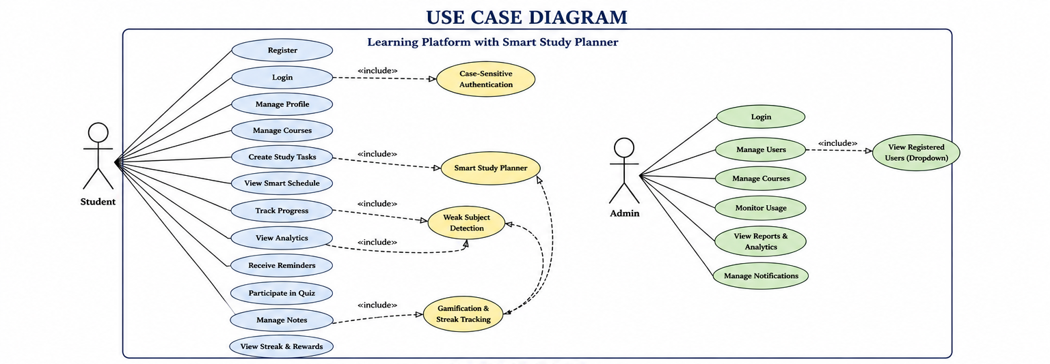

CLASS DIAGRAM

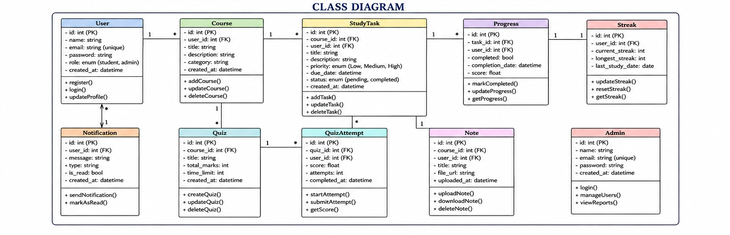

SECURITY FEATURES
- JWT Authentication
- Case-sensitive login
- Encrypted passwords
- Secure APIs
- Protected database access
These features protect user data and system resources.

Snapshort:
DashBoard page
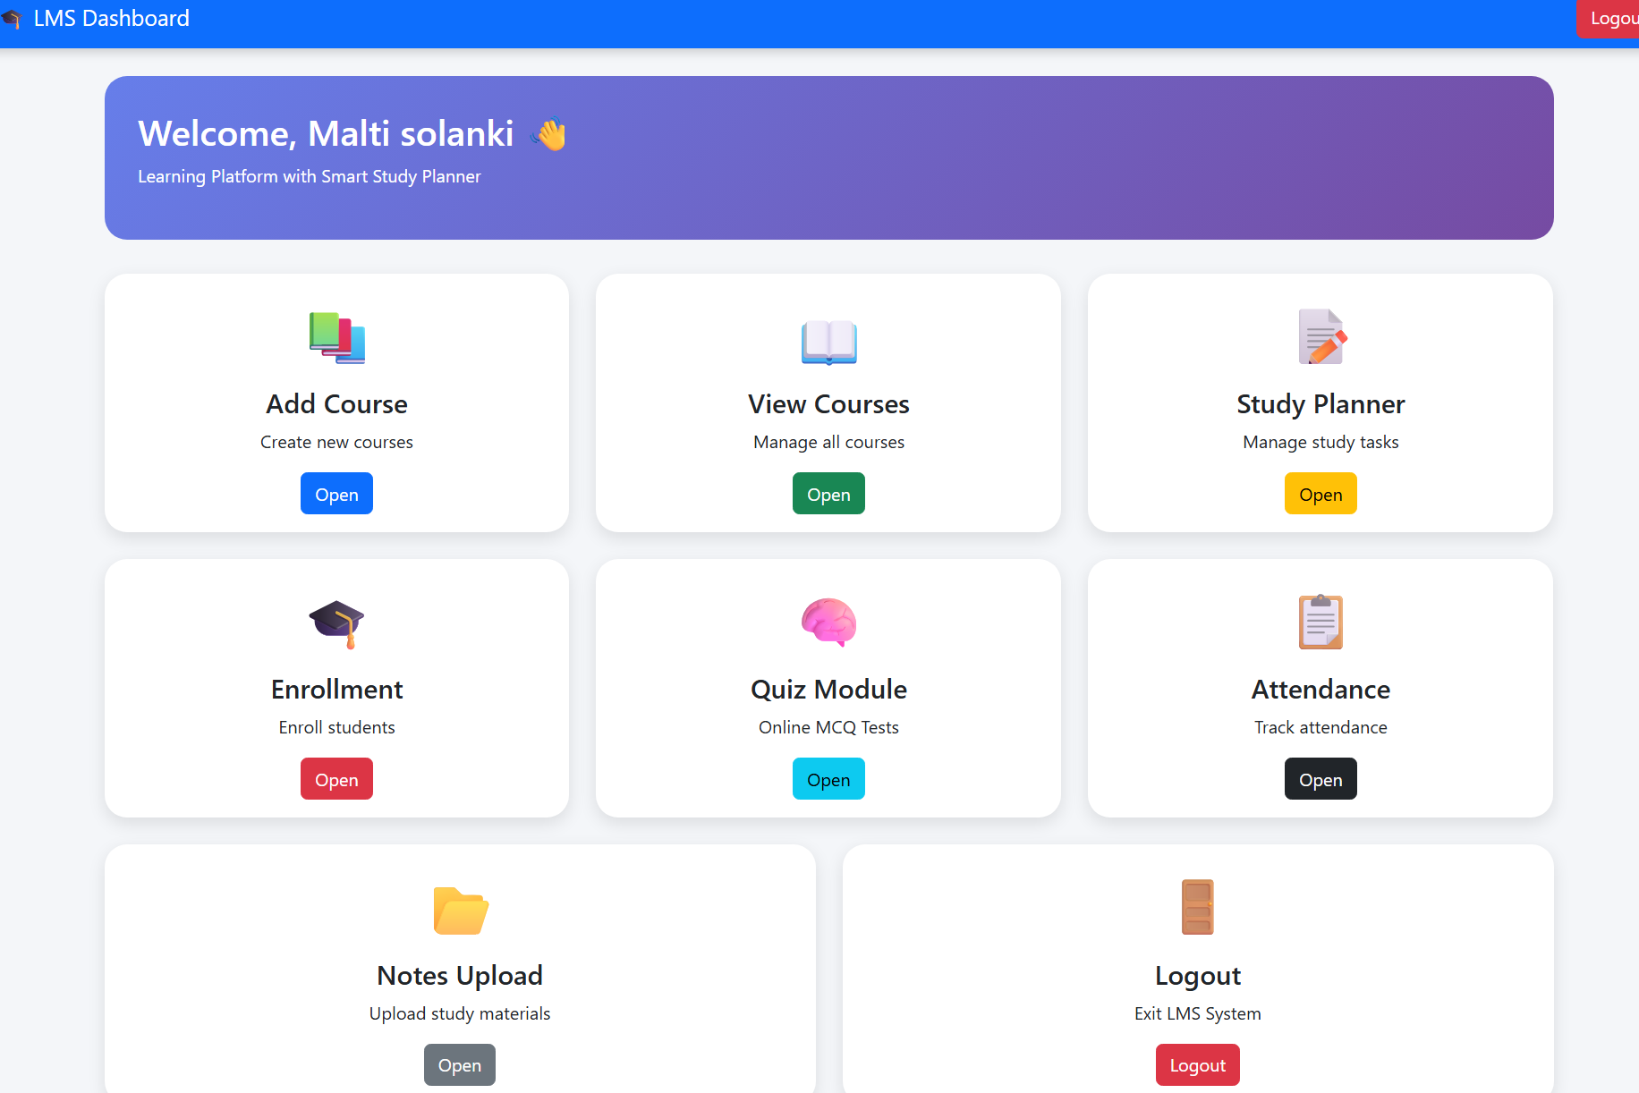

Registration Page:

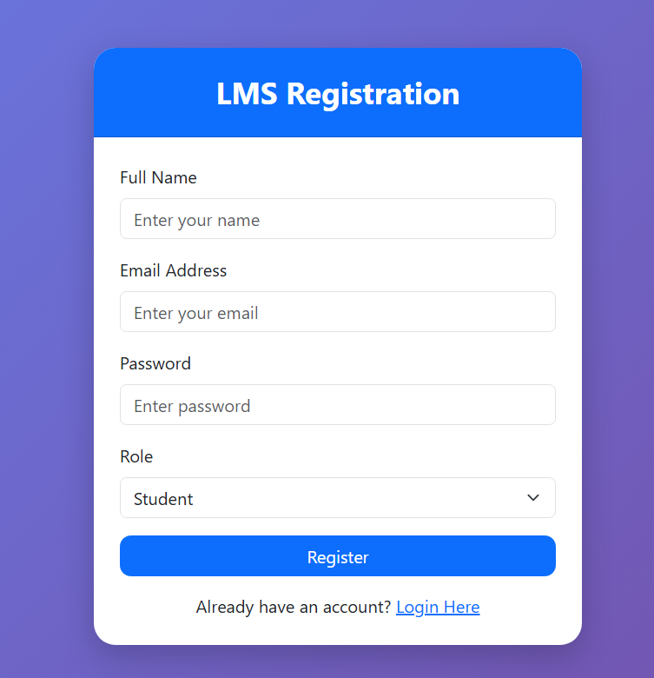

Login Page:
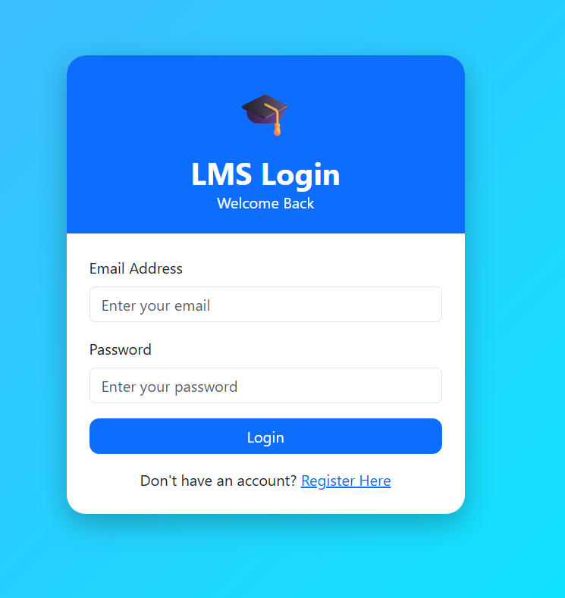

Course Page:
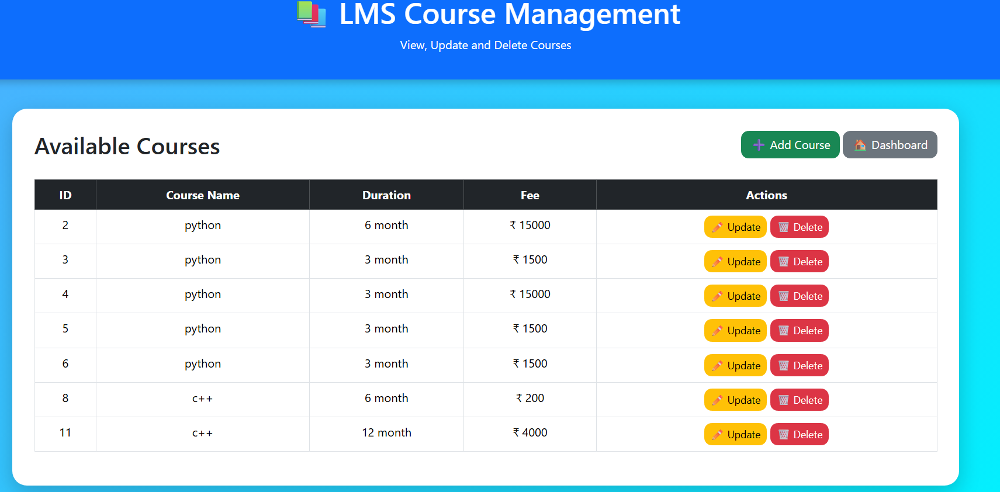

Study planner:
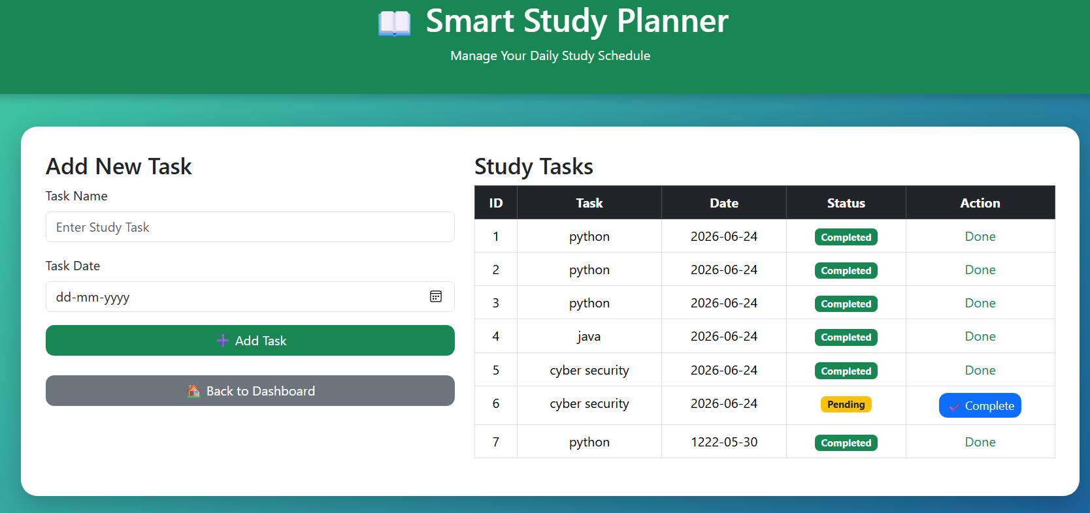

Student Enroll page:
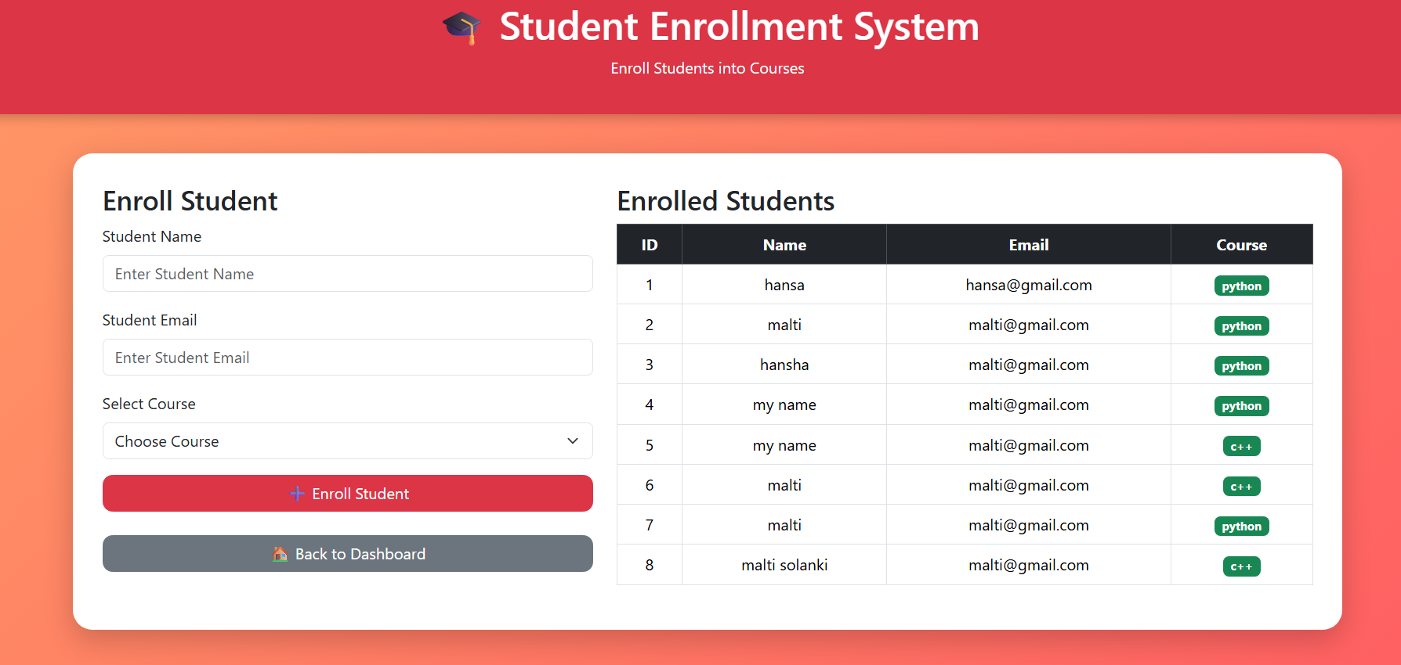

Conclusion
The Learning Platform with Smart Study Planner is a modern productivity-focused educational platform. The system combines learning management with intelligent scheduling and analytics.
The project helps students improve consistency, productivity, and academic performance through digital tools and smart planning features. The platform also supports administrators with analytics and monitoring capabilities.
The project successfully demonstrates the integration of modern web technologies with educational management systems.

